


January 2026
St. James
4-H Newsletter

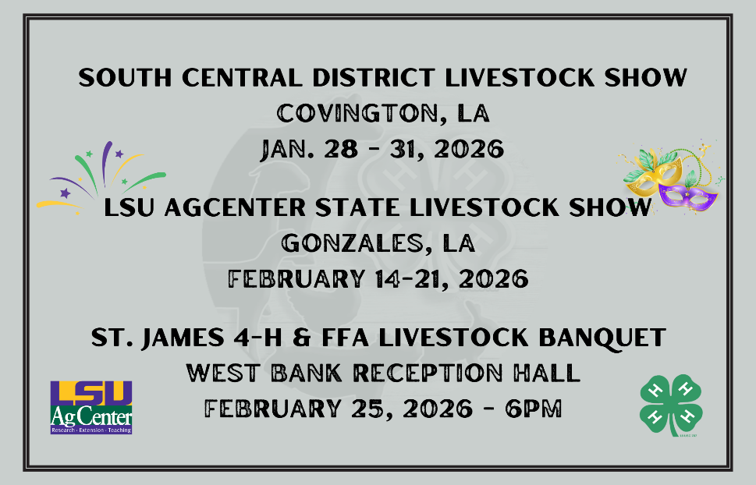


4-H Draw-A-Dairy Billboard Contest
Calendar of Events
JANUARY
10: Parish Livestock Show Set Up Day 8am-12pm
14: Jr. Leader Meeting
15: Sewing Club
16: St. James 4-H Poultry and Rabbit Show 6pm
21: Dairy Posters Due
23-24: Parish Livestock Show
26: Regional Shooting Sports Paperwork Deadline
28-31: South Central District Livestock Show

FEBRUARY
6: Food Challenge Registration Deadline
6: JLC Registration Deadline
6: Valentine Cards Due
12: Jr. Leader Meeting
13: Honor Cord Apps. Due
13: Mardi Gras Float Judging
14-21: State Livestock Show
18: Senior Scholarship Apps. Due
19: Sewing Club
21: Food Challenge Reg. Deadline
25: Parish Livestock Banquet
27: Person of Char. Essays Due

MARCH
4: 4-H U Info Meeting
6-8: JLC
10: Food Challenge
12: Jr. Leader Meeting
20 - April 4: Southern Regional Shooting Sports Matches
19: Sewing Club
20: Safety Poster & Slogans Due
23: Spring Cookery Drop-off
27: Record Books Due
PURPOSE: For 4-H club members to:

- Learn more about milk and milk products and their importance to healthy bodies
- Demonstrate communication skills by drawing a billboard encouraging or promoting the consumption of milk and/or milk products.
- Share their knowledge with others

4-H club members are to draw a billboard that encourages or promotes the consumption of milk and milk products from Dairy Cattle Only and their importance for health.

- Billboard design must be made on 22” x 28” regular poster board size only.

- DO NOT ATTACH anything to the poster that is more than 1/2” thick.

- Do not use the commercial brand names of products on the poster. Do not uses jingles, slogans, signs or pictures that are trademark or copyright protected on the poster.

- BE SURE to print name, address, grade in school and parish on back of the poster in the upper right-hand corner. Please fill out the reporting form completely.

- A 4-H club member is allowed to win first place in each division ONLY ONCE.

- Dairy Posters are due to the 4-H Office by January 21st at 4:30pm!

DIVISIONS: Division I - 4th, 5th and 6th grades
Division II - 7th and 8th grades
Division III - 9th, 10th, 11th and 12th grades
AWARDS:
PARISH: Rosette ribbon to first place winners. Participation ribbons - (purple, blue or red) for each 4-H’er that draws a dairy billboard (poster).

STATE: A $100 check for first place State winners in Division I, II, and III. Second place State winners in each division will receive a $75 check. Third place State winners in each division will receive a $50 check.
Senior Honor Cord Applicaations
In an effort to recognize graduating 4-H seniors, the Louisiana 4-H Foundation sponsors the 4-H Honor Cord Award. Please visit the following 4-H Honor Cord application link for award criteria and information.
For 4-H youth to receive the 4-H Honor Cord, they must meet the following requirements:
- Be a currently enrolled 4-H member and in good standing
- Must be a graduating senior.
- Must have been enrolled in 4-H for at least 3 years in high school.
- Must have participated in at least one state sponsored 4-H program in the past 3 years, or demonstrated exemplary parish-level program involvement.
- Must complete the application form by the deadline.
2023-24 4-H Honor Cord qualification information and application link:
https://www.lsuagcenter.com/topics/kids_teens/events/awards/recognition-and-opportunities/senior-honor-cords
Applications are due Wednesday, February 13th at 11:59pm!


Valentine Card Contest
This is a service project to honor senior citizens. After the contest, all cards will be given to senior residents of St. James Parish at Chateau St. James and Beacon Behavioral Hospital residents.
Instructions:
- Create a sturdy Valentine card appropriate for a senior citizen. Your card will be judged on the FRONT design only. Be creative and colorful. You may glue or attach small decorations to the card, but no wire or glitter is allowed. 3-D designs are allowed.
- Neatly write one of the verses below in the inside of your card, using your school 4-H Club.
- Cut out and complete the ENTRY FORM below. Paper clip/Tape it to the BACK of your Valentine card.
- Bring your Valentine card to school by Friday, February 6th.
Roses are Red,
Violets are Blue,
It’s Valentine’s Day,
And we care about you!
Happy Valentine’s Day
_______ 4-H Club
Sending you loving thoughts and good wishes to make your day happy!
Happy Valentine’s Day! ________ 4-H Club
Flowers and hearts are the decoration for this kind of celebration!
Happy Valentine’s Day _________4-H Club

Valentine Card Contest Registration Form

Name: _________________________________________

School: _________________________________________

Age: ________________ Grade: ____________________

Person of Character Essay
Martin Luther King, Jr. was an important American who exemplified great character. DO YOU KNOW SOMEONE WHO HAS GREAT CHARACTER? Maybe a relative, friend, teacher, pastor/priest, coach, elected official, or business owner?
Tell us about who you would choose as a PERSON OF CHARACTER! Write a SHORT ESSAY describing this person. Your essay should have between 200 and 500 words.
ALL ENTRIES MUST BE TURNED INTO THE 4-H OFFICE BY FRIDAY, FEBRUARY 27th


Follow these guidelines when entering the Essay Contest:
1. You must personally know the person you are writing about. In the essay, briefly tell how you know the person.
2. The essay should have a title and describe the character of the person selected, using at least one of the Pillars of Character.
3. This is a short essay contest. Use between 200 and 500 words.
4. You may neatly hand-write or type your entry.
5. Attach a page with YOUR NAME, SCHOOL & GRADE on your essay.
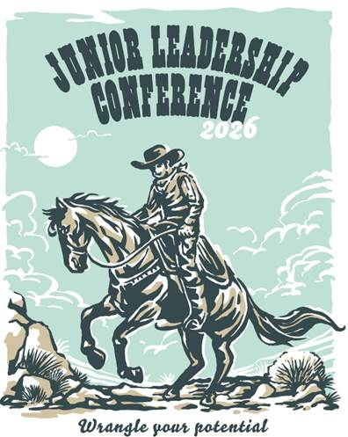
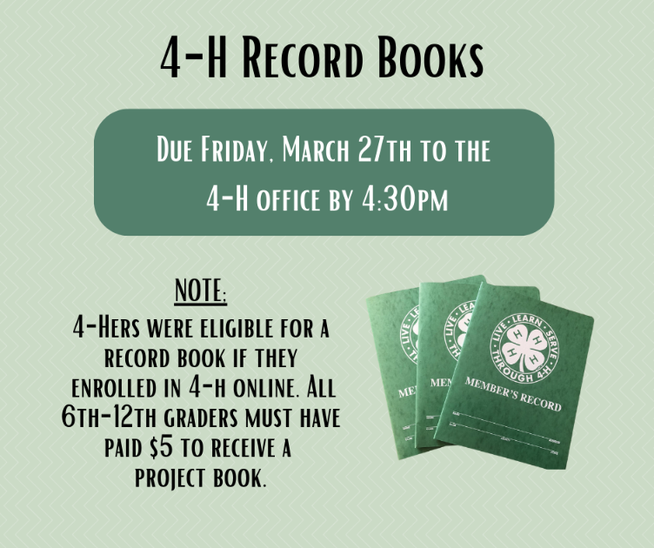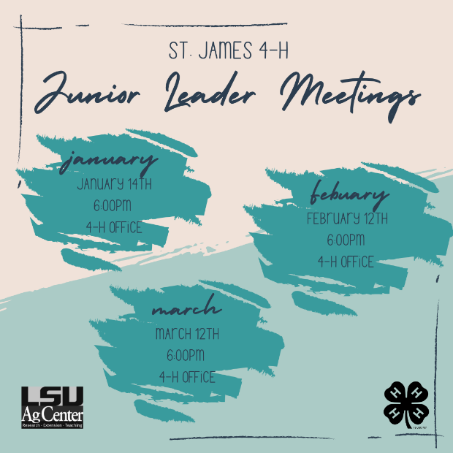


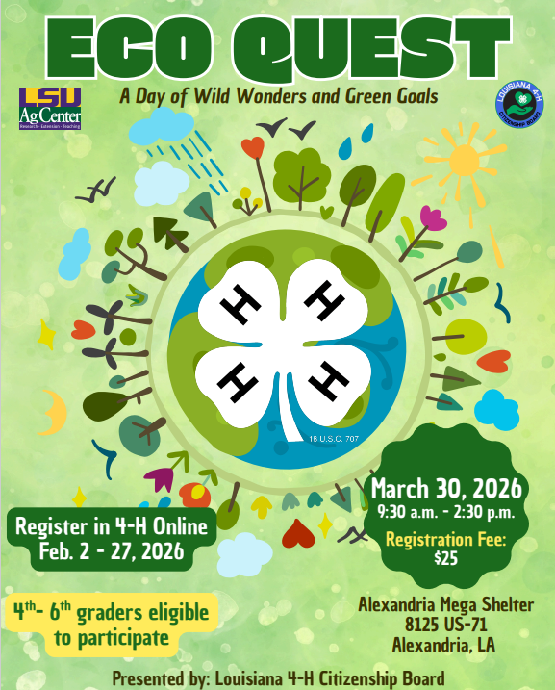



Senior Scholarships:
4-H State Scholarships
- Applicable to any 4-H senior
- Applications due Wednesday, February 18th
Evelie and Robert Scioneaux Memorial Christie Melancon Memorial
-Applicable to any 4-H Senior - Livestock Seniors
-Applications due Thursday, March 28th -Applications due Friday, January 9th

4-H Golden Clover Award
-Students 14 and under
-Must have at least 2 years of 4-H club work.
*Contact 4-H office for Application*

4-H Emerald Achievement Award
-15 years of age (or older)
-Must have 3 years of 4-H club work.
-Must have completed one year of active Junior Leadership work.
*Contact 4-H office for Application


For the latest updates and information follow us on:
Website
www.LSUagcenter.com/stjames
Facebook
www.facebook.com/St.James4H
Instagram
www.instagram.com/stjamesparish4h
Welcome Back 4-Hers!
Carly Dufresne Laynie Smith
Associate Extension Agent Associate Extension Agent
cboudreaux@agcenter.lsu.edu larceneaux@agcenter.lsu.edu

2204 S. Albert Street
Lutcher, LA 70071
(225) 562-2320

ADA: If you need a special accommodation for your participation in the event, please contact the office at 225-562-2320 at least two weeks prior to the event.
EEO: The LSU AgCenter is a statewide campus of the LSU System and provides equal opportunities in programs and employment.

